- Session and message-driven beans are EJBs, and they are often referred to collectively as enterprise beans.
In earlier versions of EJB, entities were referred to as entity beans, and they also fell into this category. In EJB 3,
however, entities are now managed by a persistence provider and not the EJB container, and they are no longer
considered enterprise beans.
2.After an EJB is instantiated inside the Java EE container, but before it is handed out to a client, the container may
initialize property data on the instance according to rules defined for that enterprise bean. This feature is called
dependency injection,and it is an example of inversion of control pattern,
3. Both enterprise beans and entities may designate some of their methods, or methods on separate classes, to be called when certain life-cycle events occur. For instance, a session bean may indicate that a certain method should be
called after the bean has been instantiated, but before it has been handed off to a client. This method may initialize
state information on the bean, or look up resources using JNDI, or any other action it wishes, provided that it does not
require a transactional context. Such callback methods are called interceptors, and they allow bean developers
to participate programmatically in the interaction between an enterprise bean, or an entity, and its container.
An important advantage of this pattern (also known as cross-cutting) is that a single interceptor may defined once
and then applied to multiple methods, or even multiple EJBs.

@ENTITY AND @TABLE ANNOTATION
For instance, by simply marking a POJO with the
@Entity annotation, all of its public properties automatically become persistent fields, and the table and column
names take on derived values that match the entity and field names. Additional annotations or XML elements are
only required when overriding the default behavior of a particular area. Only when the table name does not match the
entity name is the @Table annotation required. Great care has been taken to ensure that the default values match
the most common usages so that, in the majority of use cases, explicit metadata is not required, leading to leaner,
more clutter-free code.

Session beans are used to write business logic, maintain a conversation state for the client, and model back-end
processes or user tasks that perform one or more business operations.

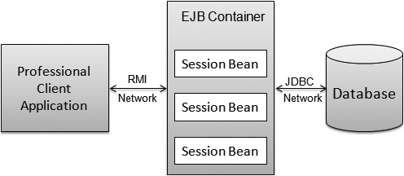
Session beans in a 3-tier architecture with a Rich Client

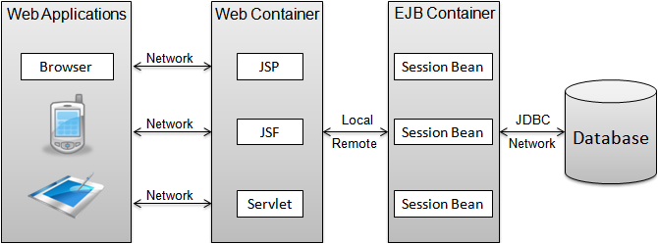
Session beans in a 3-tier architecture with a web application

Stateless session beans are comprised of the following elements:
A bean class, which contains
->the business method implementation to be executed
−> Optionally, one or more business interfaces, allowing different combinations of the bean’s
business methods to be presented to client applications

STATELESS

A stateless session bean class is any standard Java class that has a class-level annotation of @Stateless. If deployment
descriptors are used instead of annotations, then the bean class should be denoted as a stateless session bean in the
ejb-jar.xml descriptor. If you use both annotations and deployment descriptors (mixed mode), then the @Stateless
annotation must be specified if any other class-level or member-level annotations are specified in the bean class. If
both annotations and deployment descriptors are used, then the settings or values in the deployment descriptor will
override the annotations in the classes during the deployment process.

Following are two such callbacks for stateless session beans:
• PostConstruct: Denoted with the @PostConstruct annotation. Methods on the bean class
that use a specific signature, as described below, can be marked with this annotation.
• PreDestroy: Denoted with the @PreDestroy annotation. Again, any method in the bean class
with a specific signature, as described below, can be marked with this annotation.
Callback methods defined on a bean class should have the following signature:
void <METHOD>()
Callback methods can also be defined on a bean’s listener class; these methods should have the following signature:
void <METHOD>(Object) where Object may be declared as the actual bean type, which is the argument passed to the callback method at run time. Lifecycle callback methods can have public, private, protected, or package level access. A lifecycle callback method must not be declared as final or static.

